ROTARY CLUB OF HASSAN
Rotary International — District 3181

MINUTES OF MEETINGS
Rotary Year 2026–27
RI Theme: "Creating Lasting Impact"
Team AIKYAM
MEETING 2
Installation Ceremony — Rotary Year 2026–27

Date | 9 July 2026
Venue | Nanda Gokula Convention Hall, Hassan
Meeting Type | Installation Ceremony
PROCEEDINGS
The Installation Ceremony for the Rotary Year 2026–27 was held with great enthusiasm and dignity at Nanda Gokula Convention Hall, Hassan.
The ceremony marked the formal installation of the new leadership team of the club. Rtn. Dr. Geetha Kiran A assumed office as the President, Rtn. Sunitha Somashekar as the Secretary, Rtn. Nirmal Kumar Jain as the Treasurer, along with the installation of the Board of Directors, Office Bearers, and newly inducted members for the Rotary Year 2026–27.
The responsibilities of the club were ceremonially handed over by the Immediate Past President, Rtn. Mahesh D. R., to the newly installed President, Rtn. Dr. Geetha Kiran A.
The Installation Officer and Chief Guest, Rtn. Keshav H. R., Past District Governor (PDG), Rotary International District 3181, officially installed the President and the new Board of Directors. He also unveiled the Rotary International Theme for the Rotary Year 2026–27, "Creating Lasting Impact," inspiring members to dedicate themselves to meaningful service and sustainable community impact.
The newly inducted members, along with their family members, were formally inducted into the Rotary Club of Hassan by President Rtn. Dr. Geetha Kiran A, signifying their commitment to the ideals and values of Rotary.
In his keynote address, Rtn. Keshav H. R. shared his Rotary journey, valuable experiences, and vision for Rotary, motivating members to uphold the motto "Service Above Self."
Following the installation:
- President Rtn. Dr. Geetha Kiran A delivered her gratitude and acceptance address, expressing sincere appreciation to the members for their confidence and outlining her vision and commitment towards impactful service during the Rotary year.
- Secretary Rtn. Sunitha Somashekar presented the action plan and proposed activities for the Rotary Year 2026–27.
- The entire programme was gracefully anchored by Rtn. Pradeep, who ensured the smooth and successful conduct of the ceremony.
The ceremony concluded with fellowship, congratulations to the newly installed team, and best wishes for a successful and impactful Rotary year.
PHOTOGRAPHS
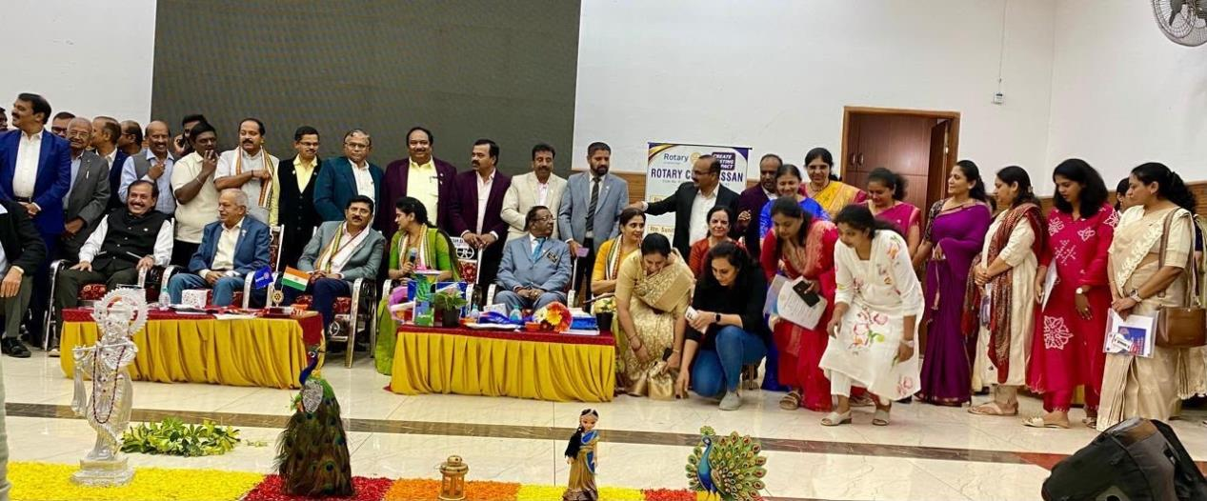
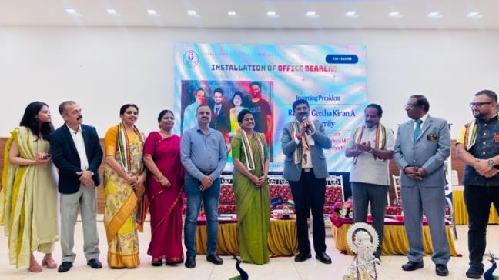 | 